**Android Application that Writes Data to the SD Card**

Aim:

To develop a Android Application that writes data to the SD Card.

**Procedure:**

Creating a new project:

* Open Android Studio and then click on **File -> New -> New project.**

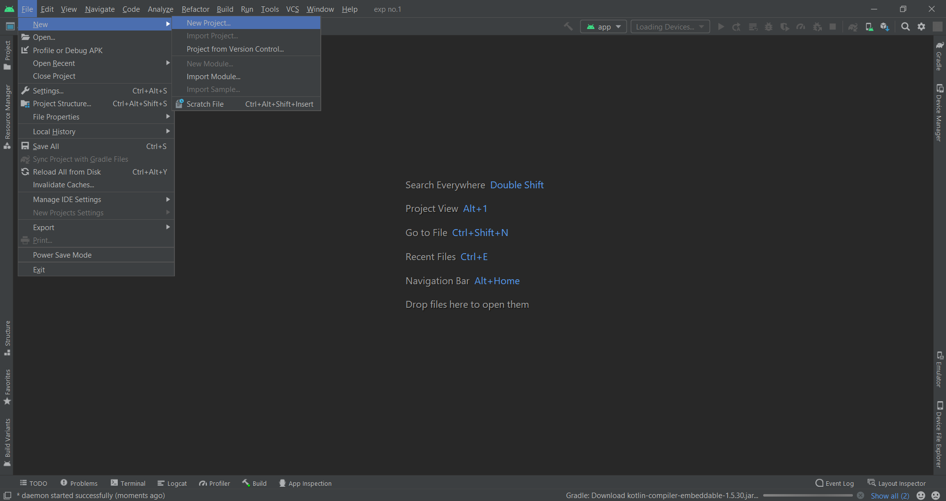

* Then type the Application name as “**expno.8″** and click **Next.**

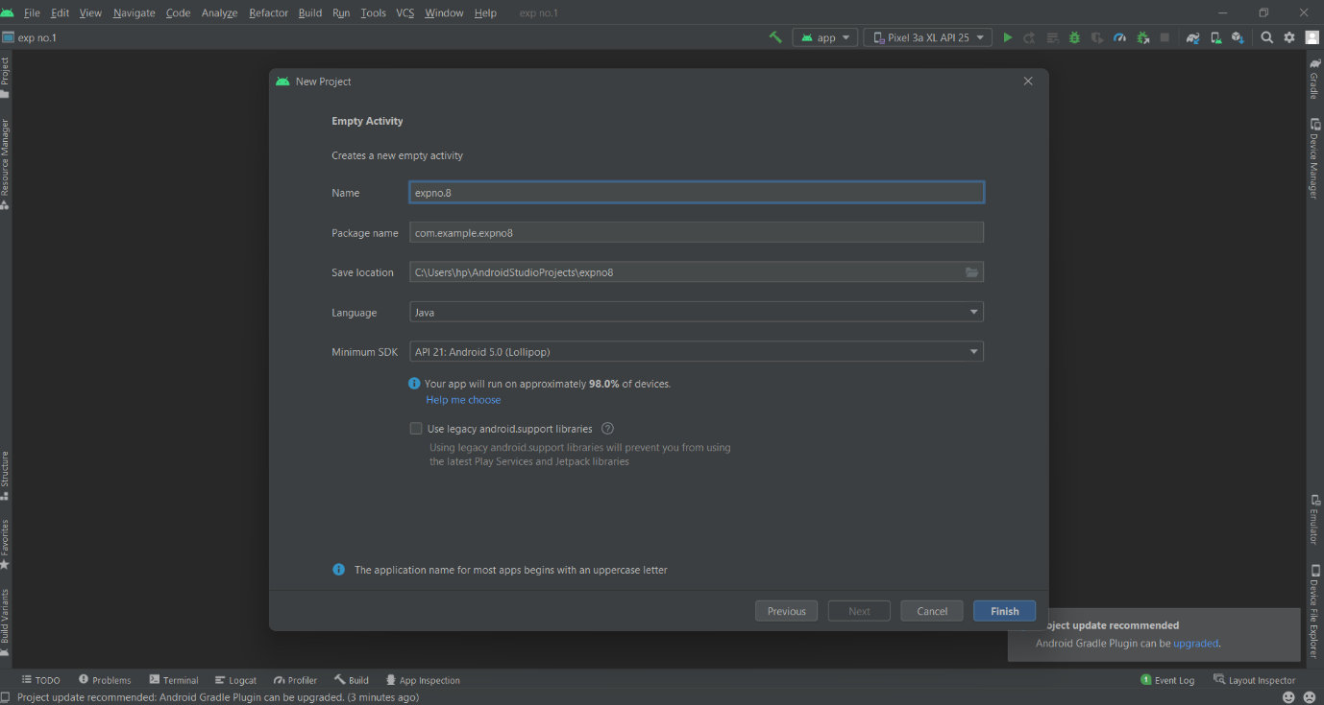

* Then select the **Minimum SDK** as shown below and click **Next**.
* Then select the **Empty Activity**and click **Next.**

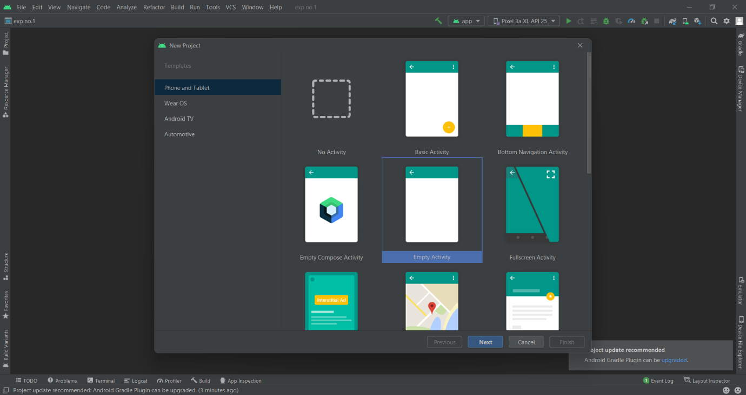

* Finally click F**inish**.
* It will take some time to build and load the project.
* After completion it will look as given below.

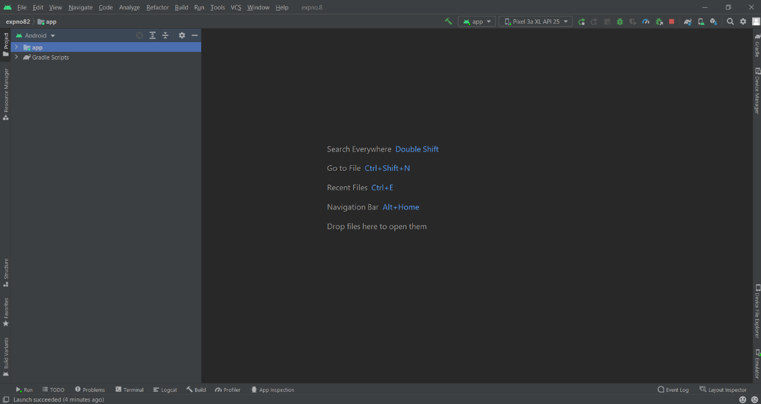

Designing layout for the Android Application:

* Click on **app -> res -> layout -> activity_main.xml.**
* Now click on **Text** as shown below.

Experiment 8-

**MainActivity.java**

package com.example.expno8;  
  
import android.Manifest;  
import android.content.pm.PackageManager;  
import android.os.Build;  
import android.os.Bundle;  
import android.os.Environment;  
import android.view.View;  
import android.widget.Button;  
import android.widget.EditText;  
import android.widget.TextView;  
import android.widget.Toast;  
import androidx.appcompat.app.AppCompatActivity;  
import androidx.core.app.ActivityCompat;  
import java.io.BufferedReader;  
import java.io.File;  
import java.io.FileNotFoundException;  
import java.io.FileOutputStream;  
import java.io.FileReader;  
import java.io.IOException;  
import java.nio.charset.StandardCharsets;  
  
public class MainActivity extends AppCompatActivity {  
  
  
 Button btnSave, btnLoad;  
 EditText etInput;  
 TextView tvLoad;  
 String filename = "";  
 String filepath = "";  
 String fileContent = "";  
  
 @Override  
 protected void onCreate(Bundle savedInstanceState) {  
 super.onCreate(savedInstanceState);  
 setContentView(R.layout.*activity_main*);  
 btnSave = findViewById(R.id.*btnSave*);  
 btnLoad = findViewById(R.id.*btnLoad*);  
 etInput = findViewById(R.id.*etInput*);  
 tvLoad = findViewById(R.id.*tvLoad*);  
 filename = "myFile.txt";  
 filepath = "MyFileDir";  
 if (!isExternalStorageAvailableForRW())  
 {  
 btnSave.setEnabled(false);  
 }  
 btnSave.setOnClickListener(new View.OnClickListener() {  
 @Override  
 public void onClick(View view) {  
 tvLoad.setText("");  
 fileContent = etInput.getText().toString().trim();  
 if (!fileContent.equals("")){  
 File myExternalFile = new File(getExternalFilesDir(filepath),filename);  
 FileOutputStream fos =null;  
 try {  
 fos = new FileOutputStream(myExternalFile);  
 fos.write(fileContent.getBytes());  
 }catch (FileNotFoundException e){  
 e.printStackTrace();  
 } catch (IOException e) {  
 e.printStackTrace();  
 }  
 etInput.setText("");  
 Toast.*makeText*(MainActivity.this, "Information Saved To SD Card", Toast.*LENGTH_SHORT*).show();  
 }  
 else {  
 Toast.*makeText*(MainActivity.this, "Text Field Cannot be empty", Toast.*LENGTH_SHORT*).show();  
 }  
  
  
  
 }  
 });  
 btnLoad.setOnClickListener(new View.OnClickListener() {  
 @Override  
 public void onClick(View view) {  
 FileReader fr = null;  
 File myExternalFile = new File(getExternalFilesDir(filepath),filename);  
 StringBuilder stringBuilder = new StringBuilder();  
 try {  
 fr = new FileReader(myExternalFile);  
 BufferedReader br = new BufferedReader(fr);  
 String line = br.readLine();  
 while ( line !=null){  
 stringBuilder.append(line).append('\n');  
 line = br.readLine();  
  
 }  
  
 } catch (FileNotFoundException e) {  
 e.printStackTrace();  
 } catch (IOException e) {  
 e.printStackTrace();  
 }finally {  
 String fileContent = "File Contents\n" + stringBuilder.toString();  
 tvLoad.setText(fileContent);  
 }  
 }  
 });  
 }  
  
 private boolean isExternalStorageAvailableForRW() {  
 String extStorageState = Environment.*getExternalStorageState*();  
 if (extStorageState.equals(Environment.*MEDIA_MOUNTED*)){  
 return true;  
 }  
 return false;  
 }  
}

**activity_main.xml**

<?xml version="1.0" encoding="utf-8"?>  
<LinearLayout xmlns:android="http://schemas.android.com/apk/res/android"  
 xmlns:tools="http://schemas.android.com/tools"  
 android:layout_width="match_parent"  
 android:layout_height="match_parent"  
 android:background="#e8f4f8"  
 android:gravity="center"  
 android:orientation="vertical"  
 android:padding="16dp"  
 tools:context=".MainActivity">  
  
 <EditText  
 android:id="@+id/etInput"  
 android:layout_width="match_parent"  
 android:layout_height="wrap_content"  
 android:hint="Type here to save on SD card." />  
  
 <LinearLayout  
 android:layout_width="match_parent"  
 android:layout_height="wrap_content"  
 android:layout_marginTop="10dp"  
 android:orientation="horizontal">  
  
 <Button  
 android:id="@+id/btnSave"  
 android:layout_width="wrap_content"  
 android:layout_height="wrap_content"  
 android:layout_marginRight="10dp"  
 android:layout_weight="1"  
 android:background="#44a6c6"  
 android:text="Save"  
 android:textColor="@android:color/white" />  
  
 <Button  
 android:id="@+id/btnLoad"  
 android:layout_width="wrap_content"  
 android:layout_height="wrap_content"  
 android:layout_marginLeft="10dp"  
 android:layout_weight="1"  
 android:background="#44a6c6"  
 android:text="Load"  
 android:textColor="@android:color/white" />  
 </LinearLayout>  
  
 <ScrollView  
 android:layout_width="match_parent"  
 android:layout_height="80dp">  
 <TextView  
 android:id="@+id/tvLoad"  
 android:layout_width="match_parent"  
 android:layout_height="wrap_content"  
 android:text="" />  
 </ScrollView>  
  
</LinearLayout>

**AndroidManifest.xml**

<?xml version="1.0" encoding="utf-8"?>  
<manifest xmlns:android="http://schemas.android.com/apk/res/android"  
 package="com.example.expno8">  
 <uses-permission android:name="android.permission.WRITE_EXTERNAL_STORAGE"/>  
 <uses-permission android:name="android.permission.WRITE_EXTERNAL_STORAGE"/>  
  
 <application  
 android:allowBackup="true"  
 android:icon="@mipmap/ic_launcher"  
 android:label="@string/app_name"  
 android:roundIcon="@mipmap/ic_launcher_round"  
 android:supportsRtl="true"  
 android:theme="@style/Theme.Expno8">  
 <activity  
 android:name=".MainActivity"  
 android:exported="true">  
 <intent-filter>  
 <action android:name="android.intent.action.MAIN" />  
  
 <category android:name="android.intent.category.LAUNCHER" />  
 </intent-filter>  
 </activity>  
 </application>  
  
</manifest>

**Output-**